In this project, the most effort went through understanding symbols and sections by investigating object files and writing Linker script from scratch by following Eng. Kerolos tutorial.

Files description:

1. Python files:
   1. ExplainSymbols.py: It’s used by make file to generate a text file which will help understand what are the symbols in each object type and where they are located.

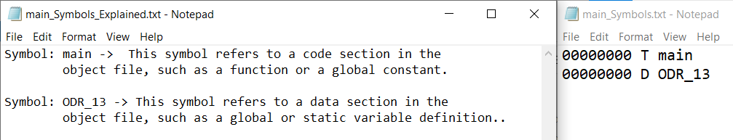

* 1. ReadSections.py: It’s a wrapper python script for arm-none-eabi-x popular function that shall be used to get a description of what’s going on in the object files and sections.

1. Main.c and startup.s are the main application and startup code.

